Michael Lee

Alex Nguyen

CS 434: Assignment 4

1. Non-hierarchical clustering – K-means algorithm
   1. We implemented the K-means algorithm for k=2 as you can see from our code in part_2_1() in main.py. We can see from the below graph that we’ve plotted, that the algorithm indeed converges and it converges fairly quickly as it bottoms out at around 5-6 iterations.

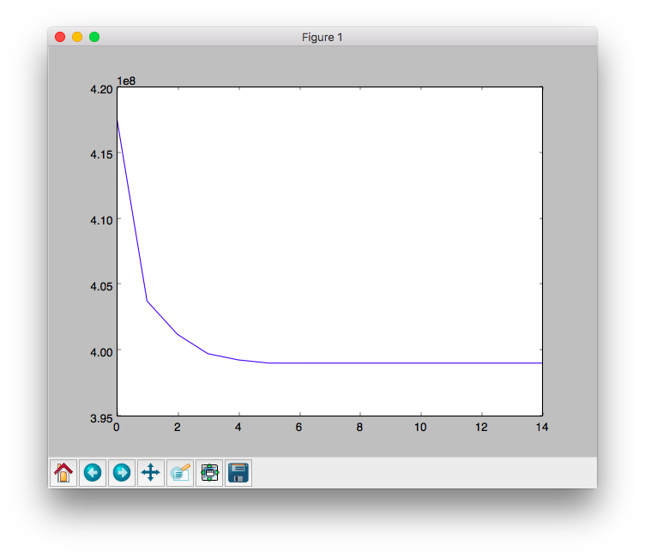

* 1. You can see the results of multiple different K=n. To choose the best k=n we would want the k that converges the fastest which would be k = 6. This would mean that our data fits most neatly into our k distinct groups.

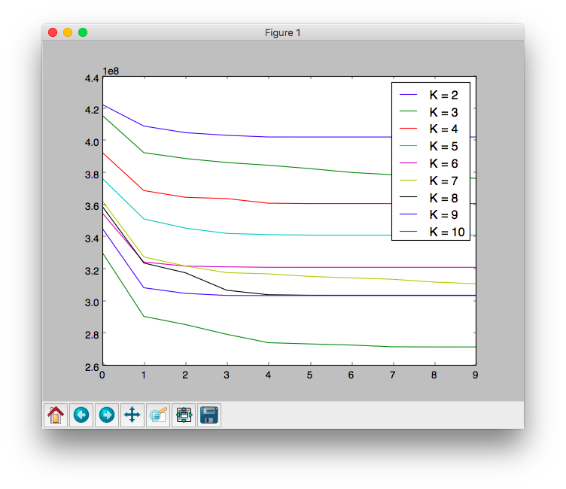

1. Hierarchical agglomerative clustering (HAC)
   1. Single Link
      1. 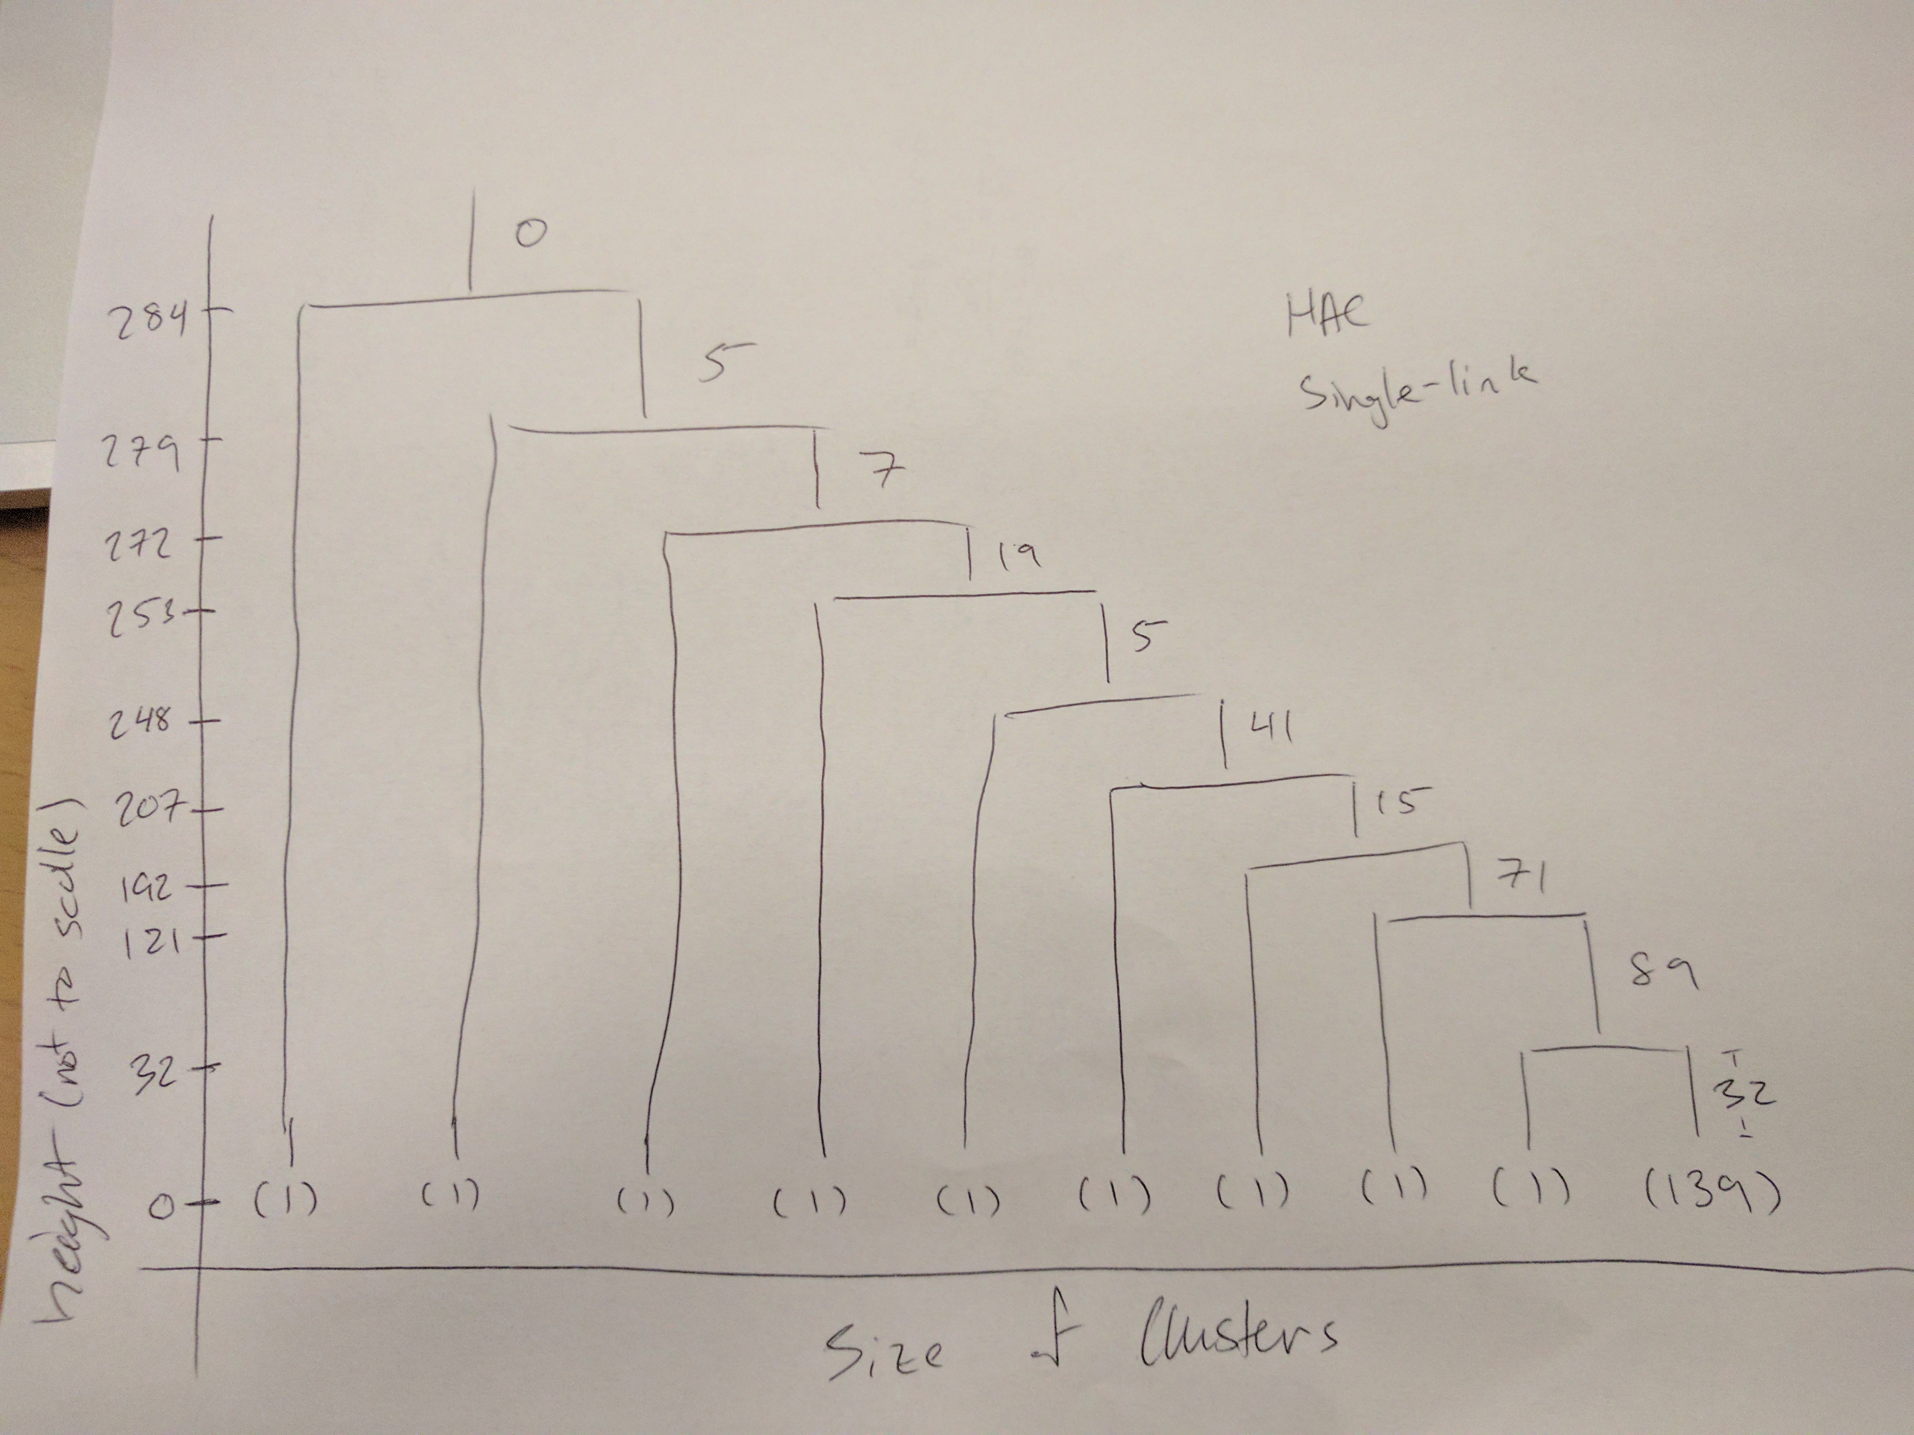
   2. Complete Link
      1. 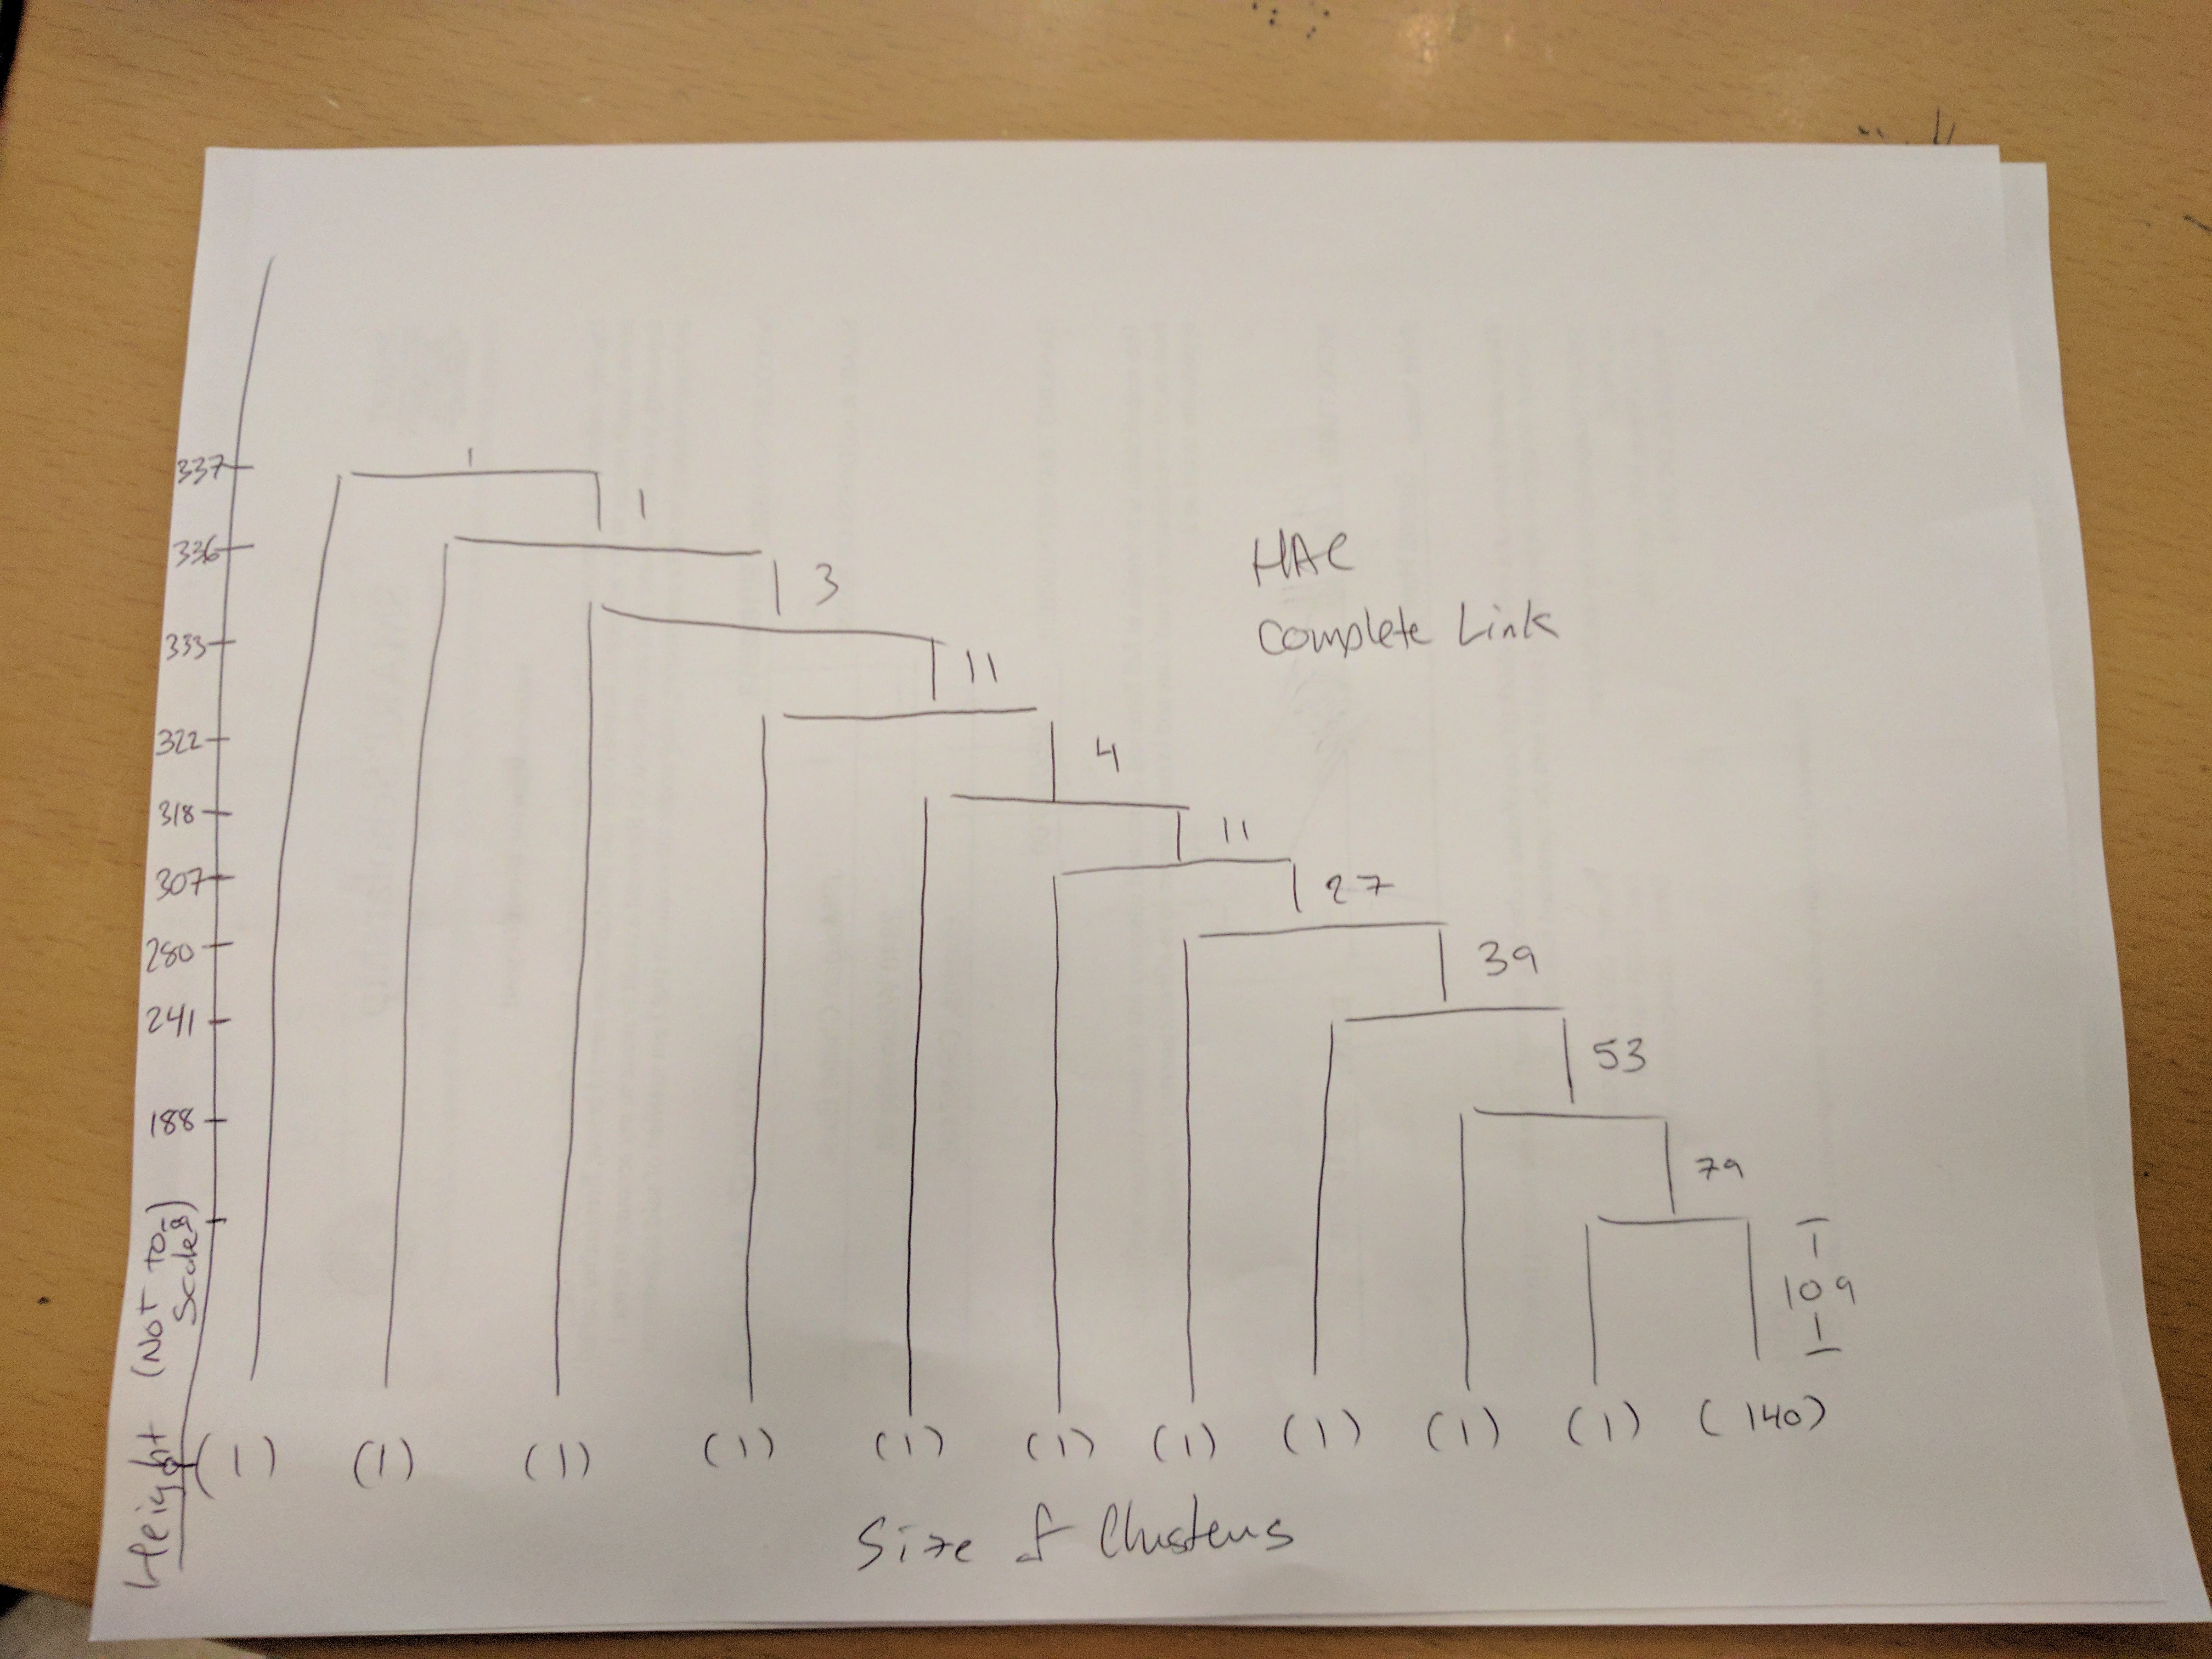
   3. Looking at both single link and complete link dendrograms, there is only one real cluster at the 10-cluster mark. There other clusters shown are single data points that are yet to be merged. This may mean that our clusters could have converged before the 10-cluster mark or a lot the data is heavily centered around one point.